**IT457 – Assignment 5**

**Varun Vyas – 202101468**

**Contents**

**1. CosmosDB 2**

**A. Populate data and query filter 2**

**B. Global distribution 7**

**C. Create a notebook 9**

**D. Log transformation 9**

**2. Web app in AWS 9**

**3. Azure App Services 18**

# **1. CosmosDB**

## **A. Populate data and query filter**

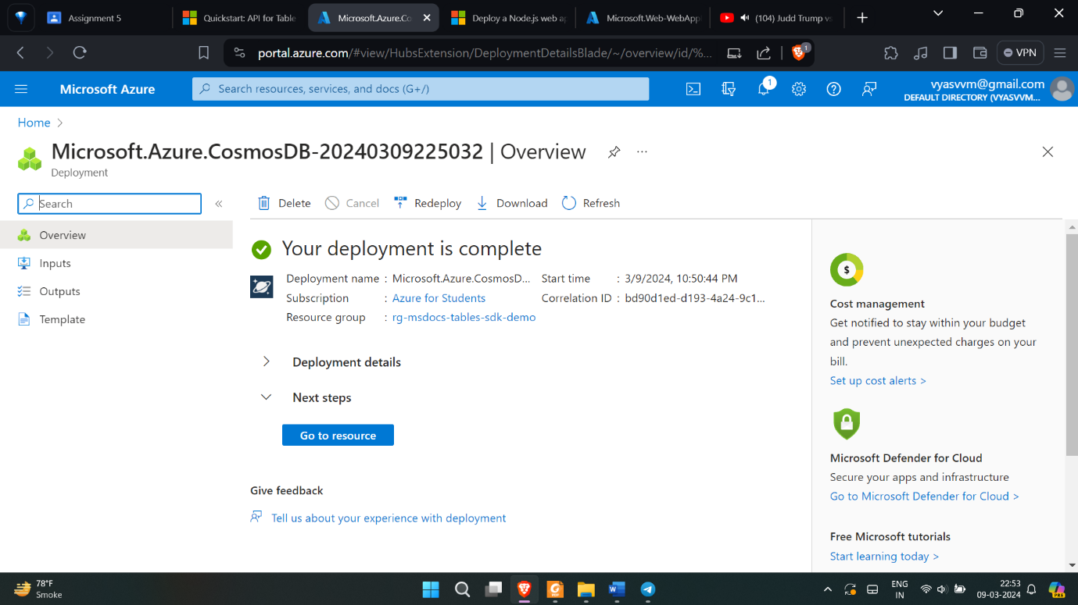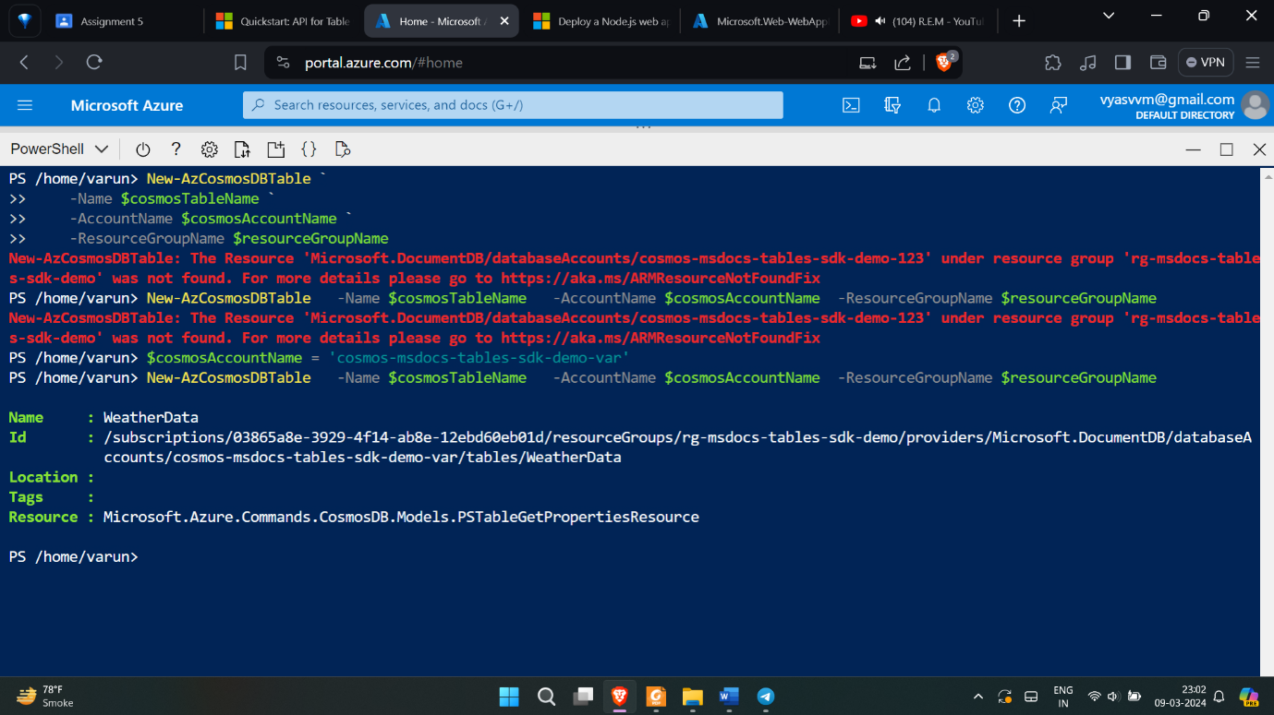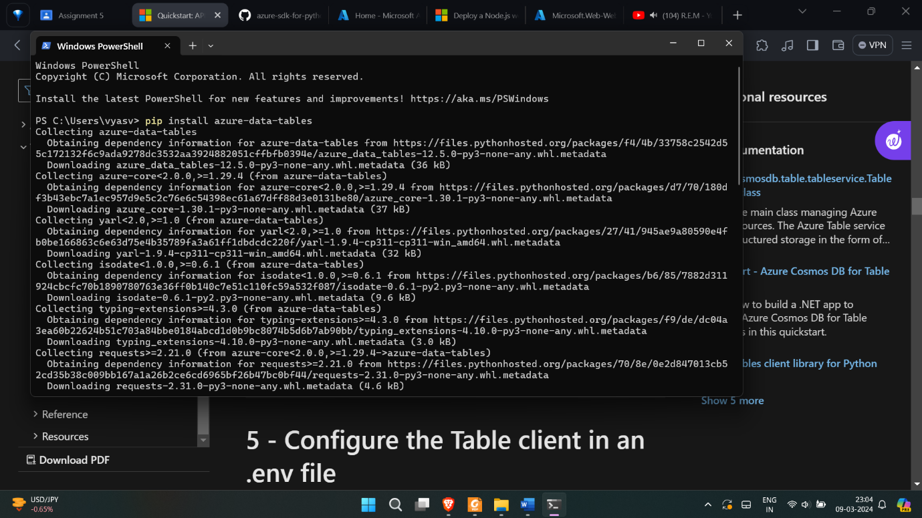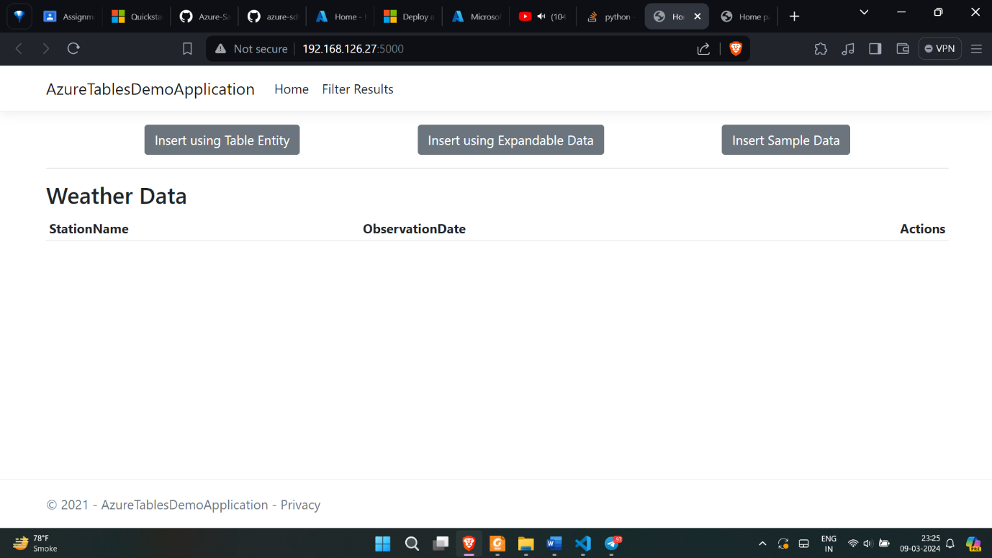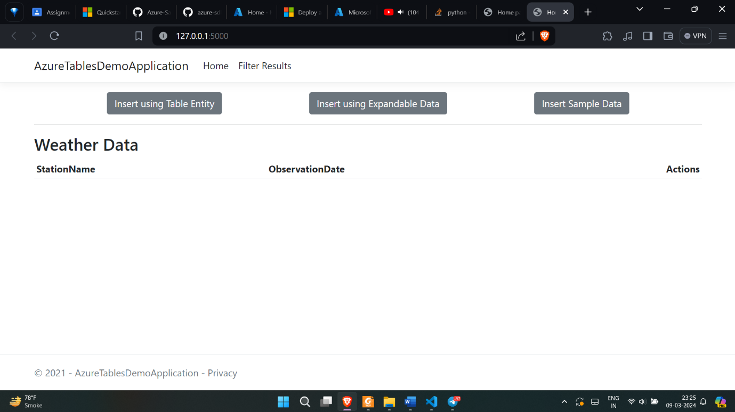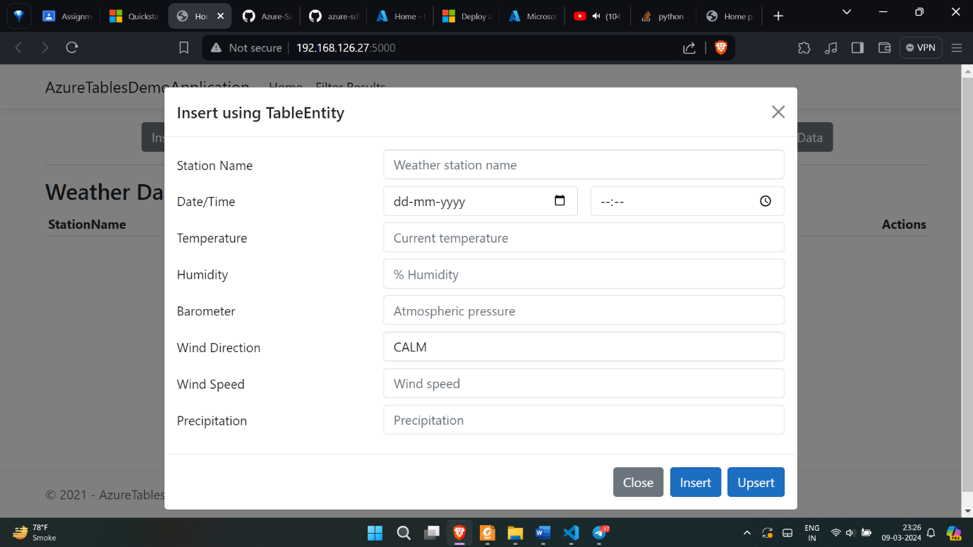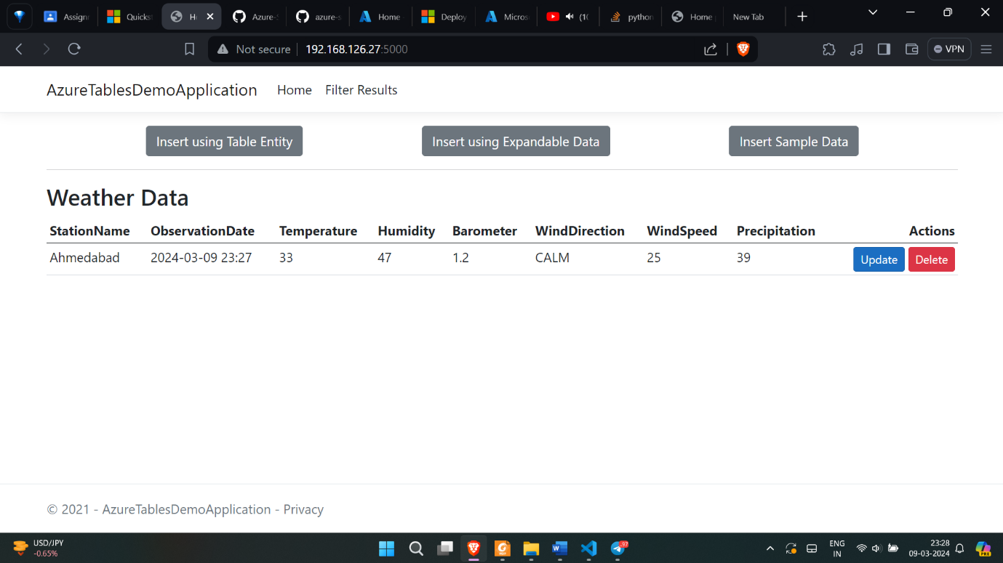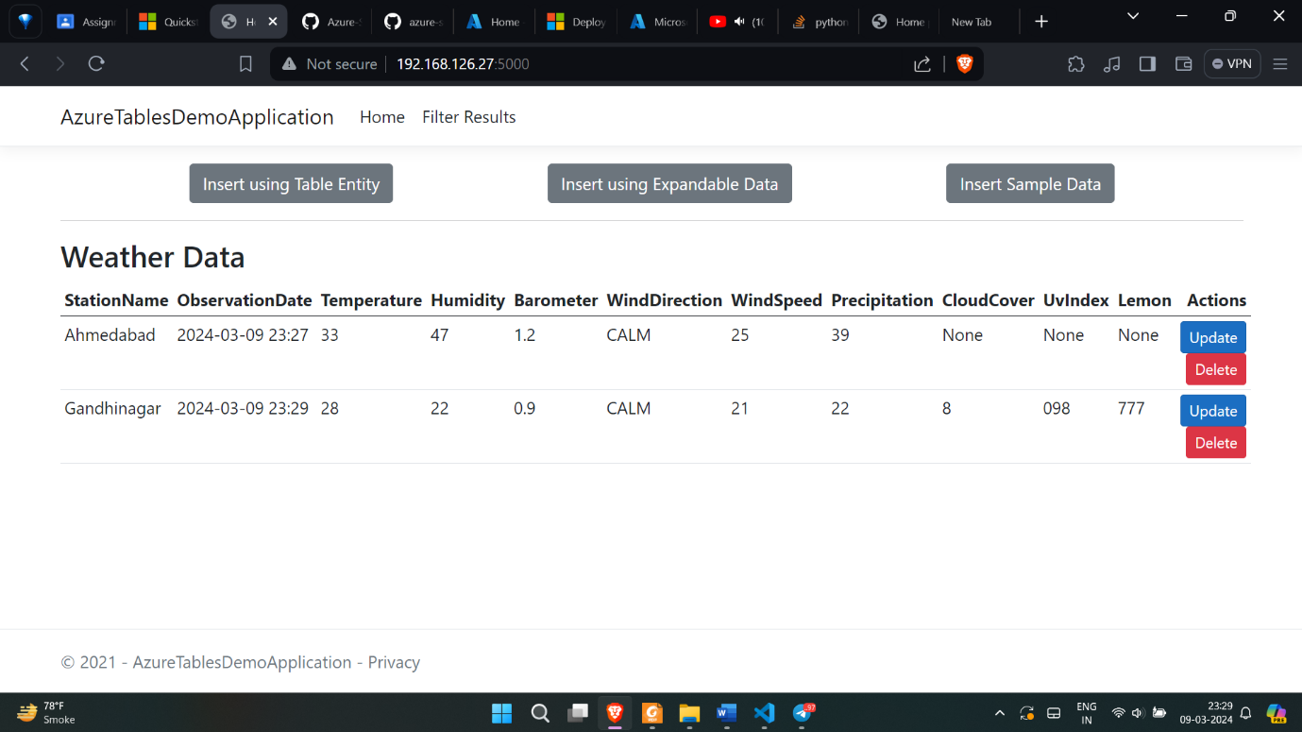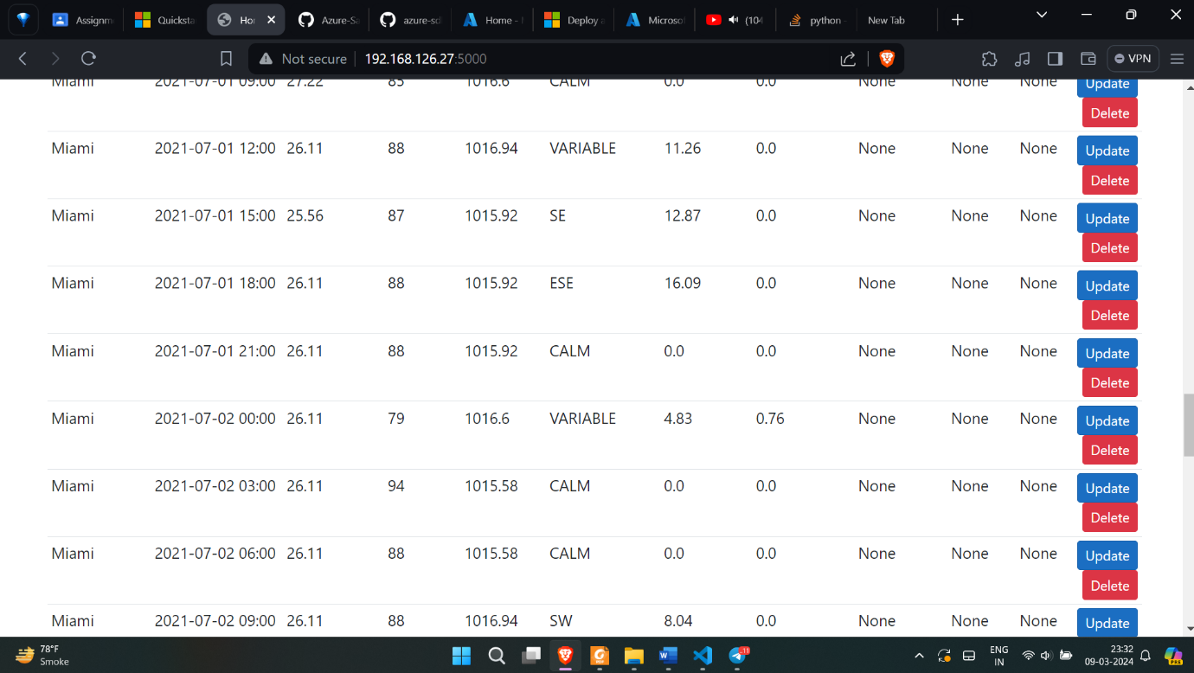

## **B. Global distribution**

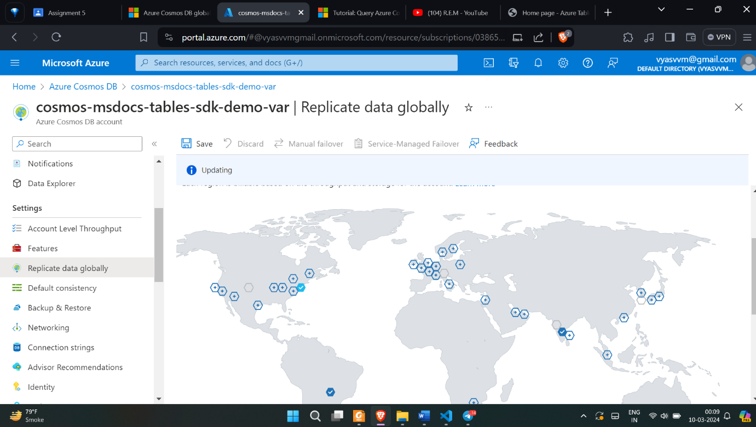

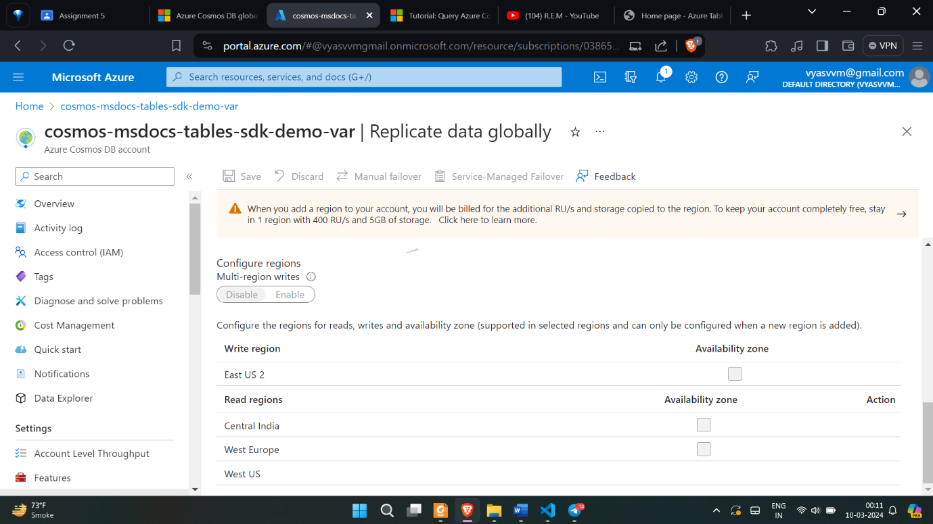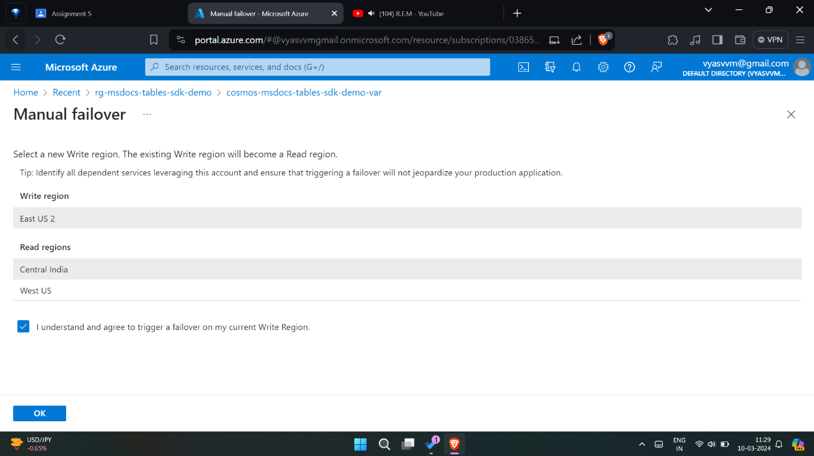

## **C. Create a notebook**

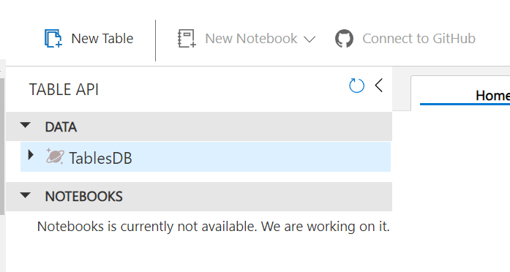

## **D. Log transformation**

# **2. Web app in AWS**

**-** [**https://aws.amazon.com/getting-started/hands-on/build-web-app-s3-lambda-api- gateway-dynamodb/**](https://aws.amazon.com/getting-started/hands-on/build-web-app-s3-lambda-api-%20gateway-dynamodb/)

**Deploying a hello world web application**

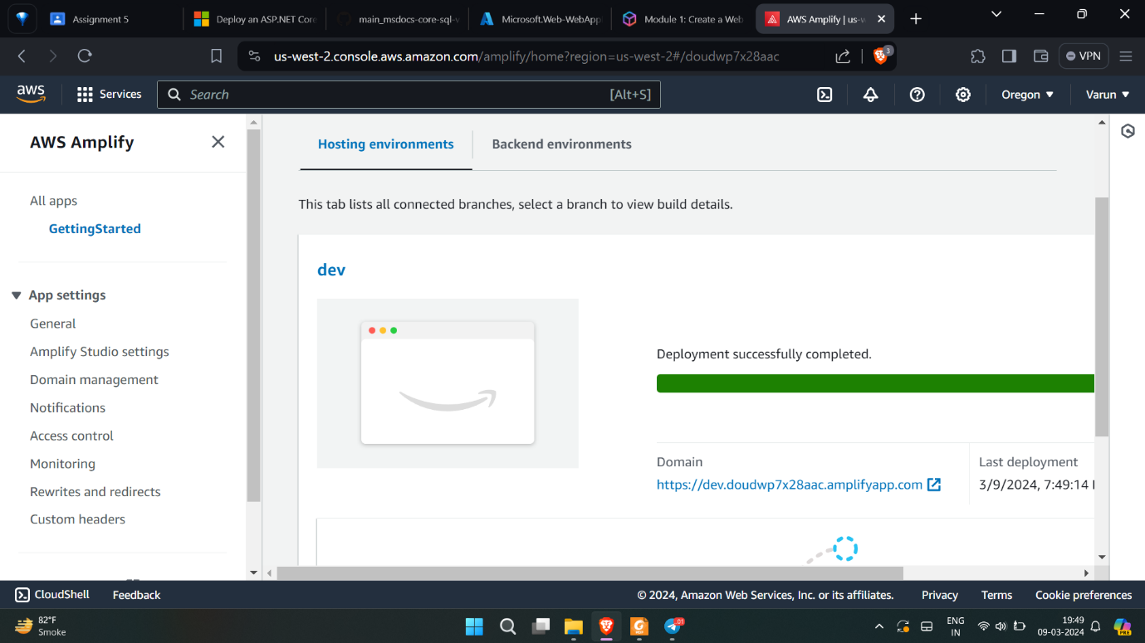

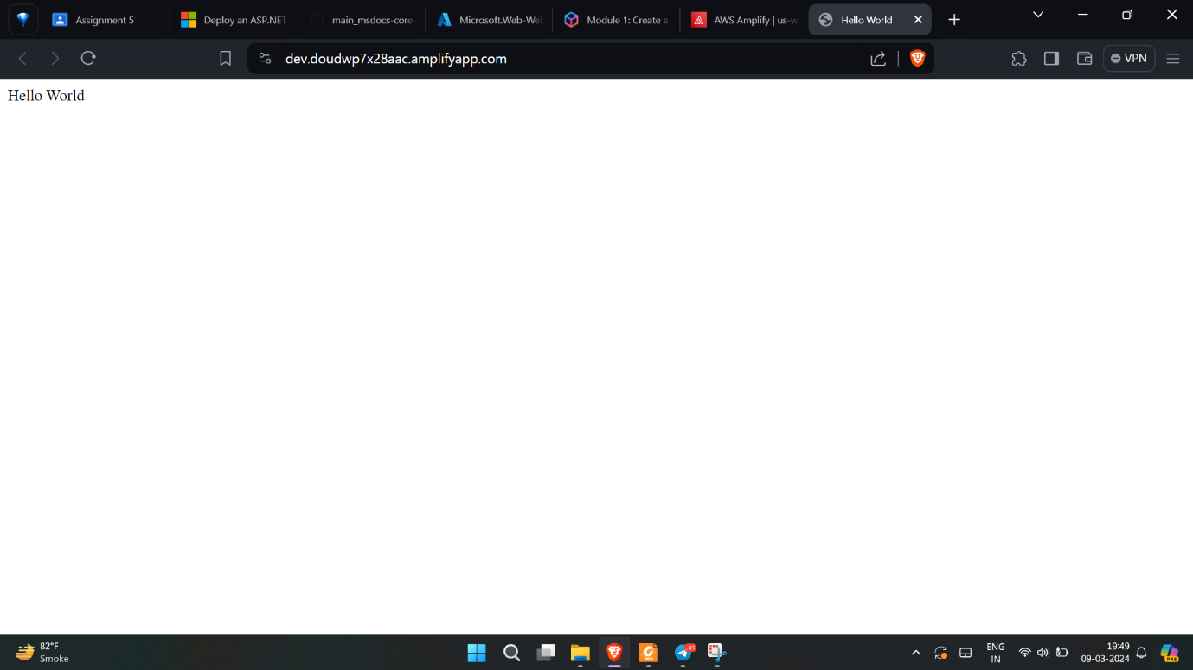

**Creating a lamda function for hello world.**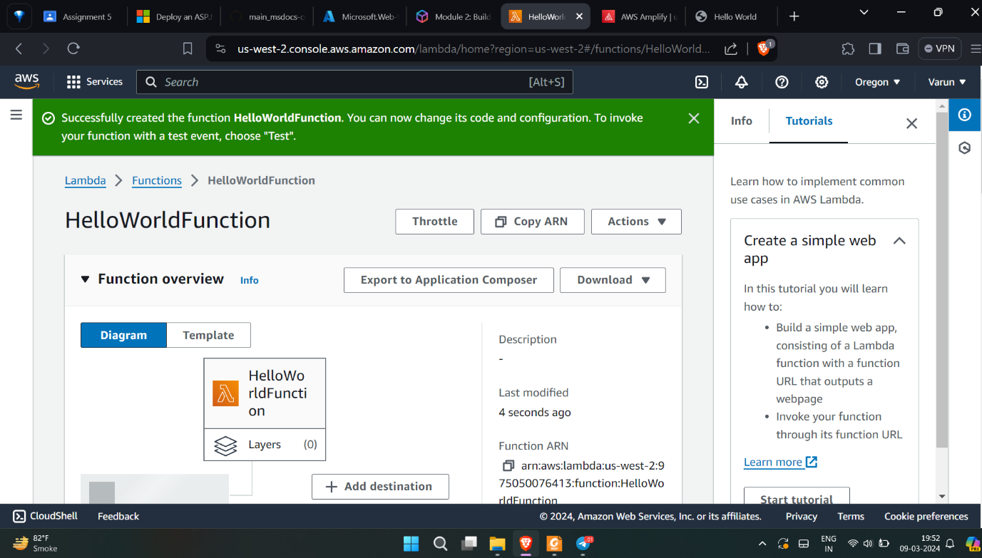

**Updating the lamda function.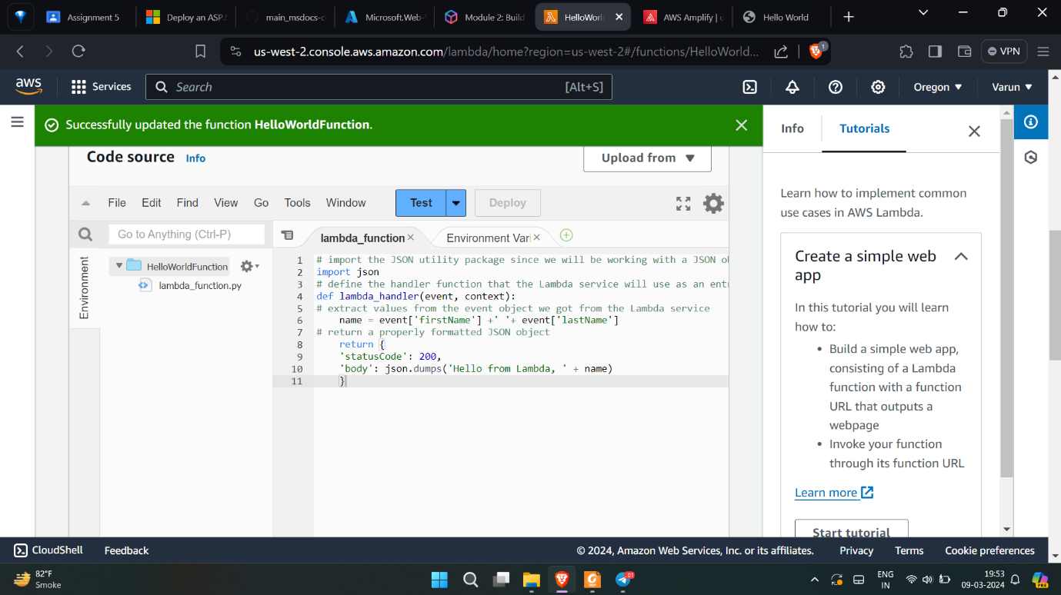Creating test event for lamda function**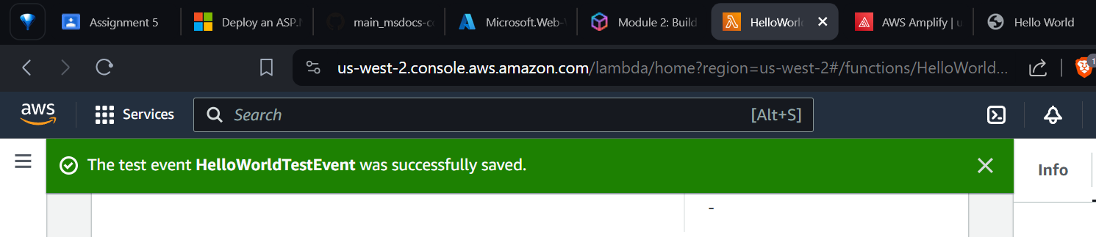

**testing the lamda function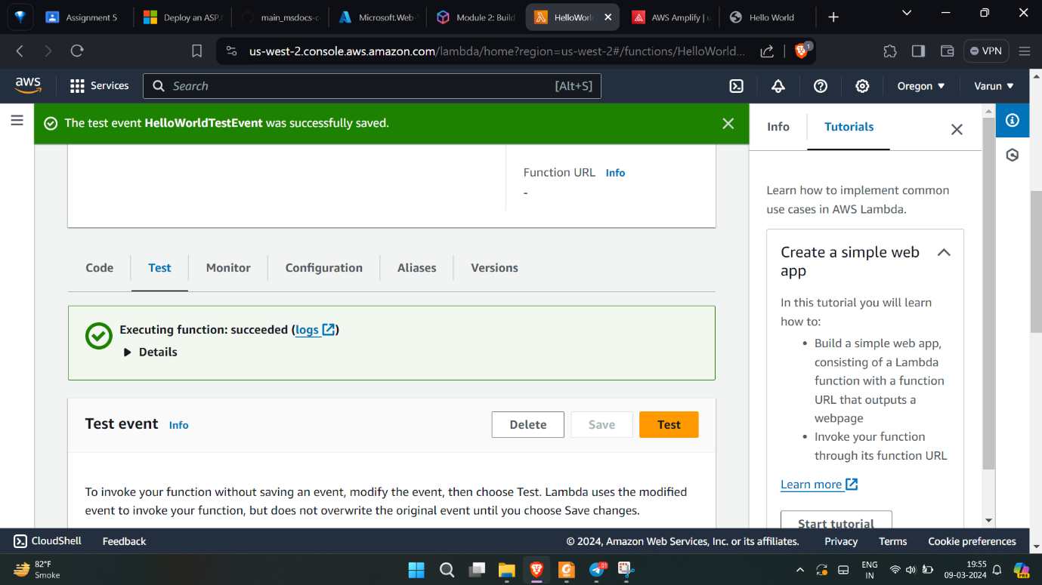Creating RESTful API**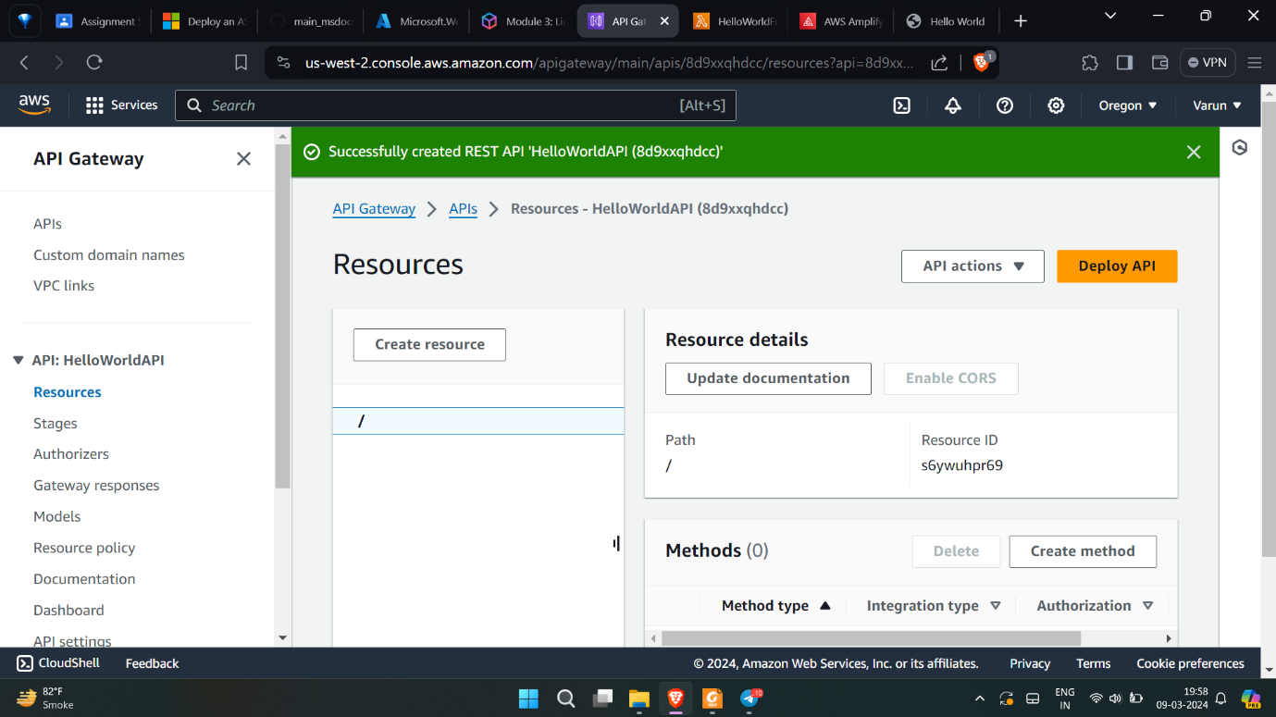

**Creating POST method in API**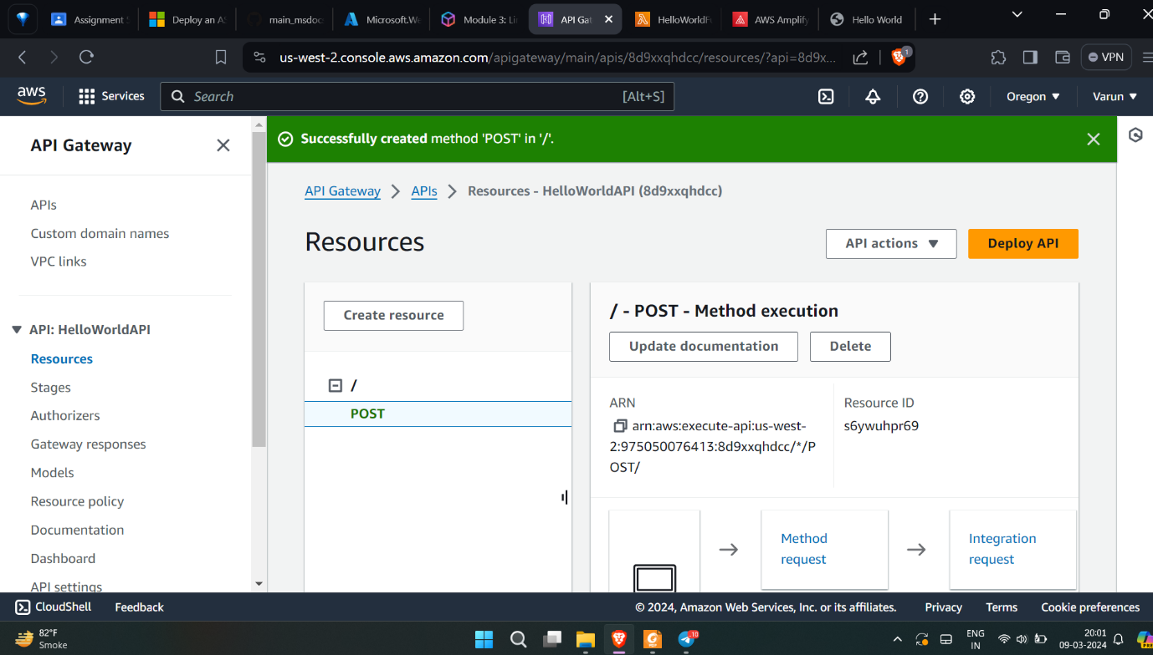

**Adding CORS to the API**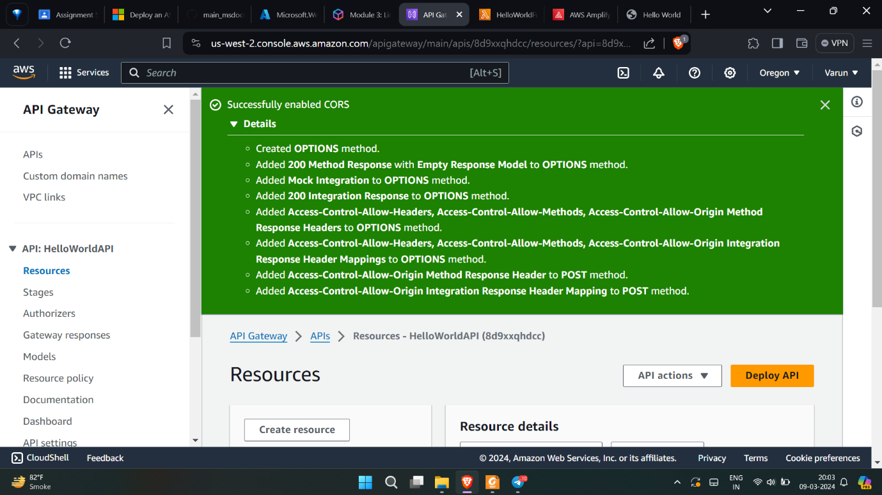

**Deploying the HELLOWORLD API**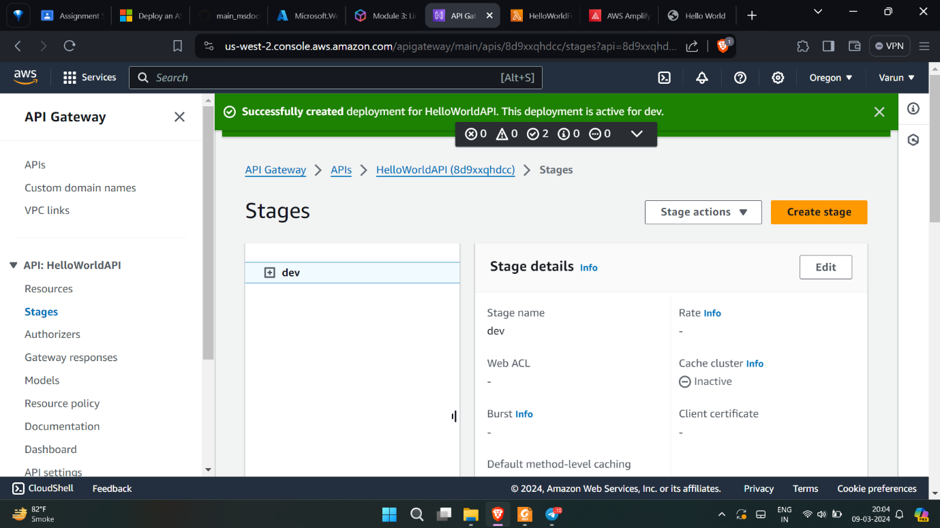

**Testing the HELLOWORLD POST API**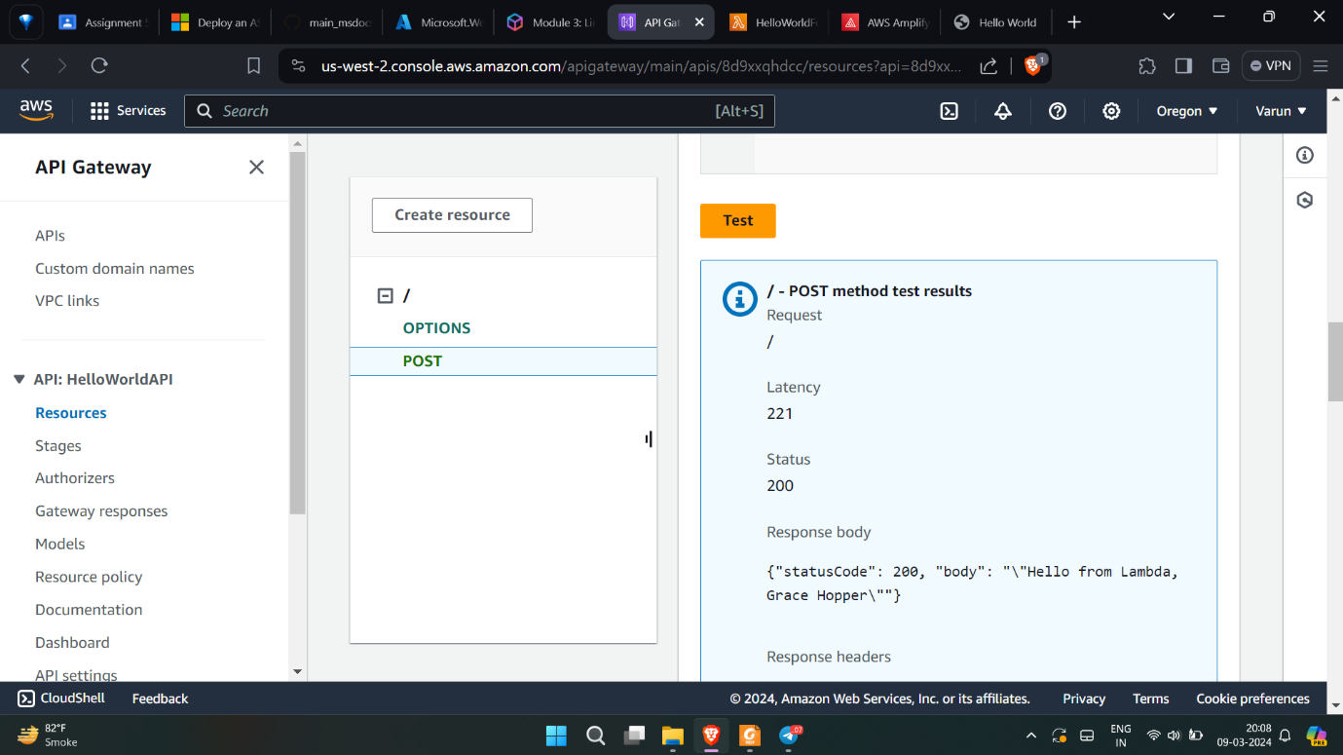

**Creating table in HELLOWORLD Database.**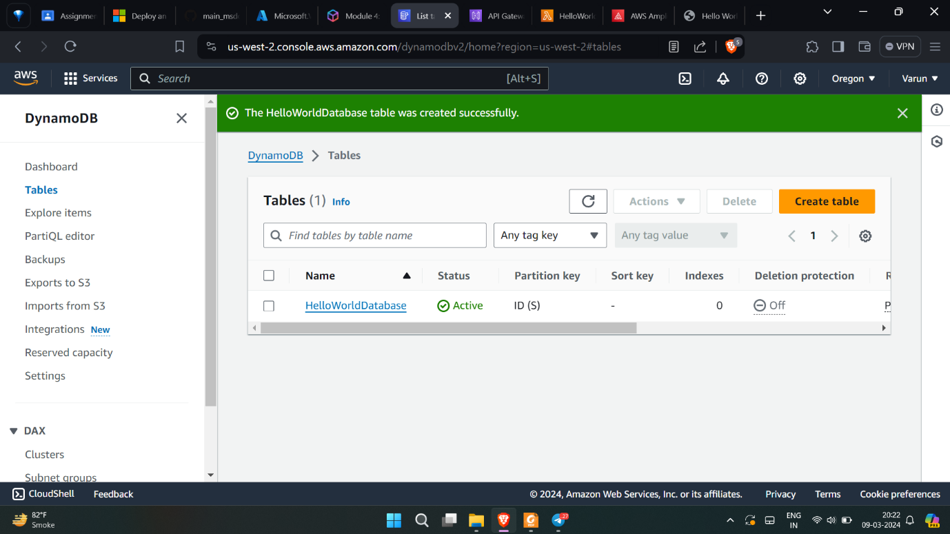

**Adding policy to allow lamda function to work in HELLOWORLDDATABSE**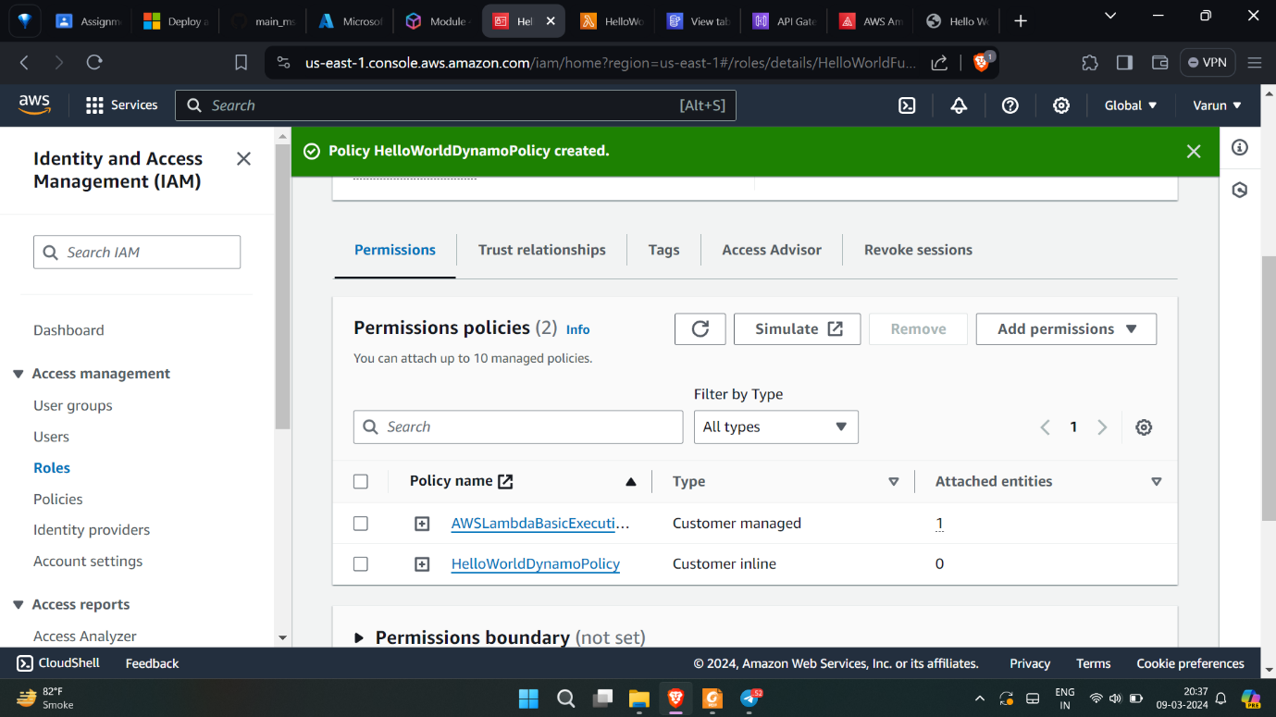

**Updating the lamda function to work on database and return the JSON fil**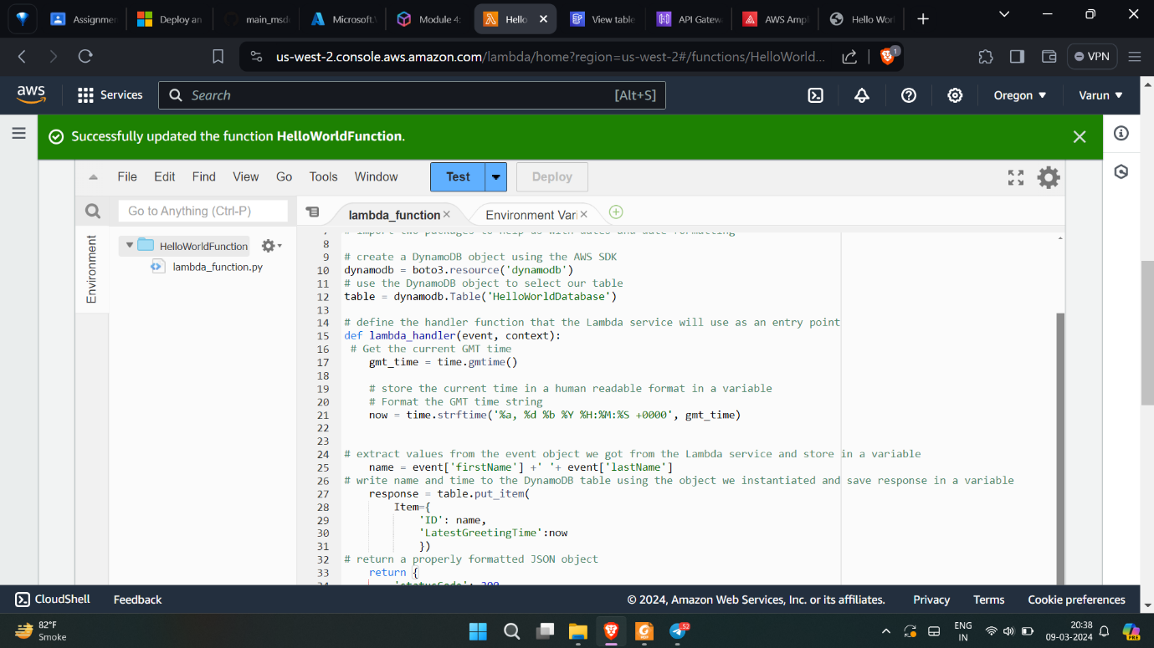

**Testing the updated function.**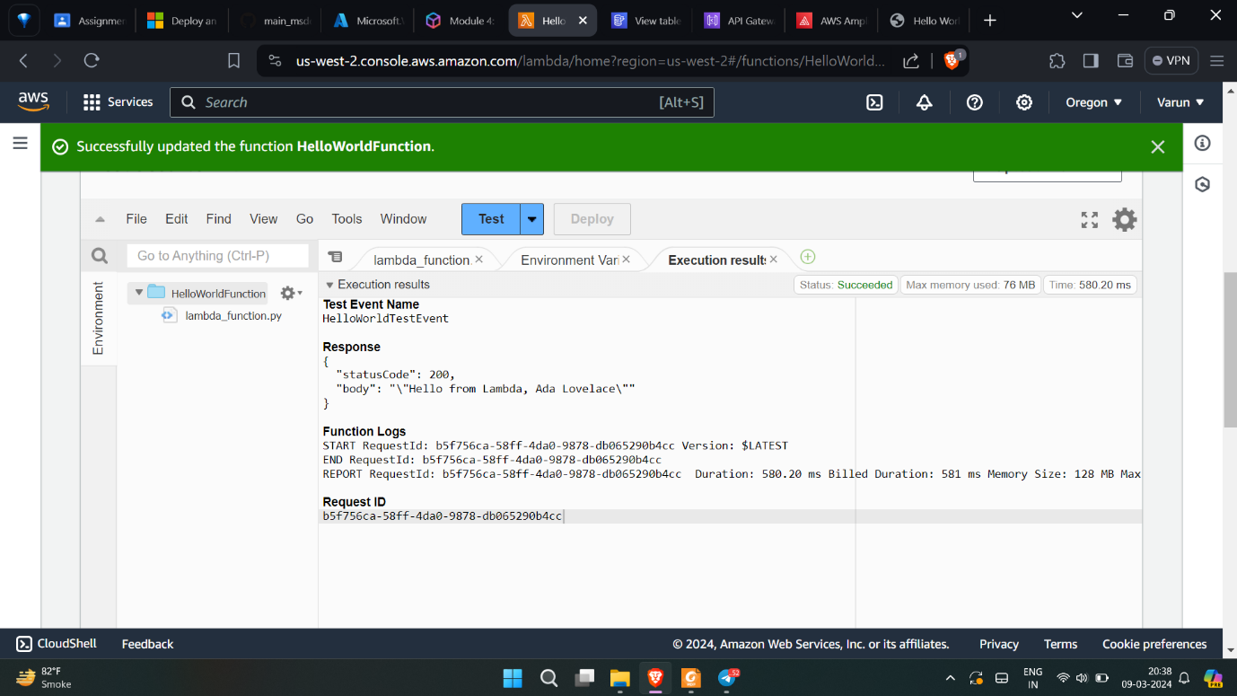

**Checking the updated entry in the table.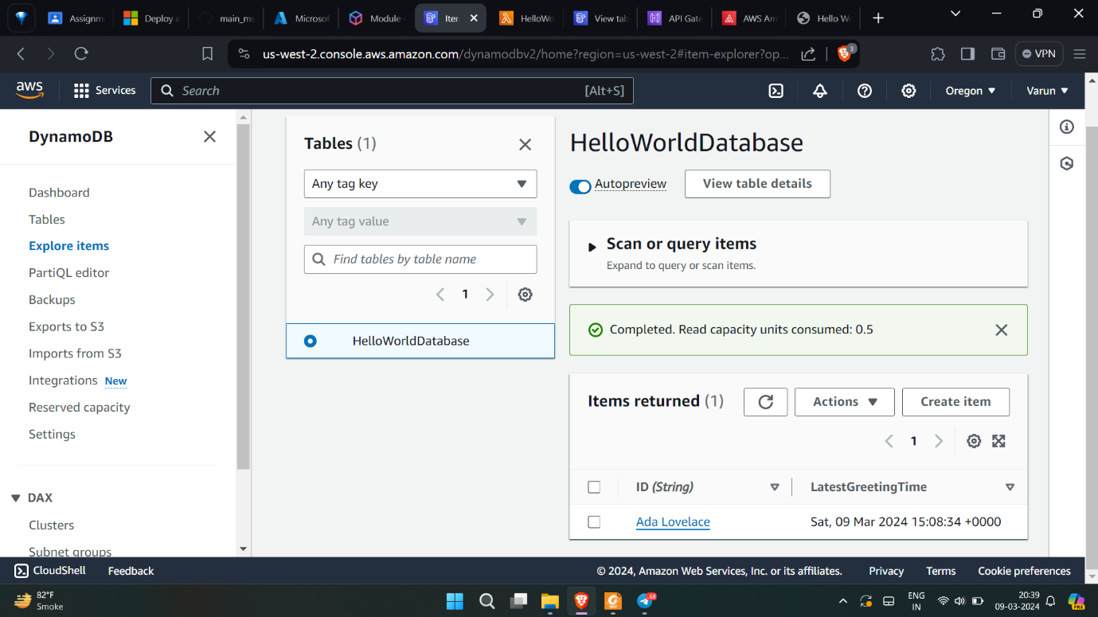Deploying a new web server code.**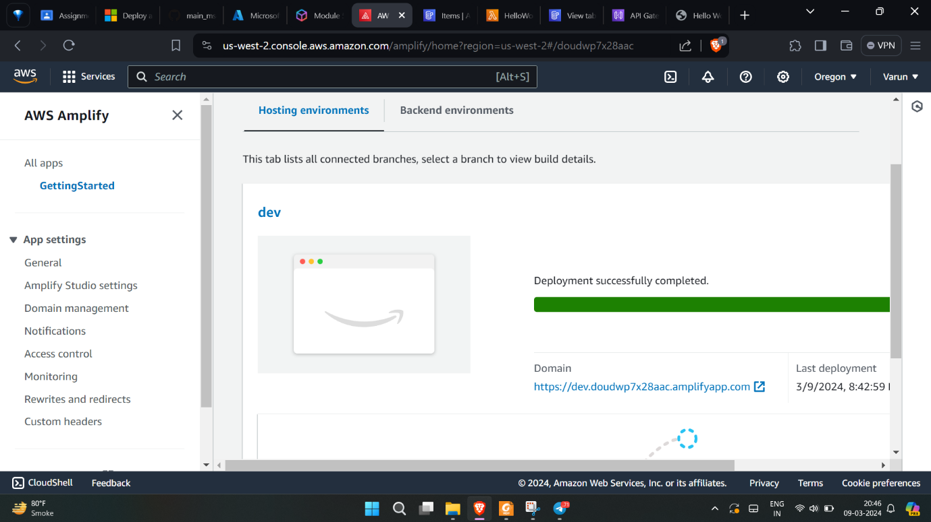

**Checking the web URL. SUCCESS!**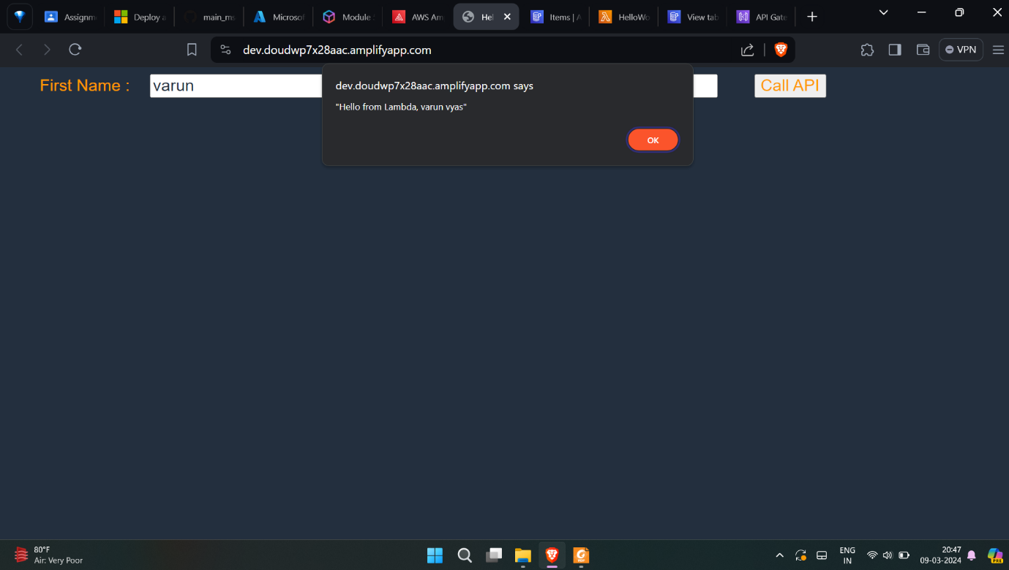

# **3. Azure App Services**

**Deploying the app service using MongoDB and NodeJS**

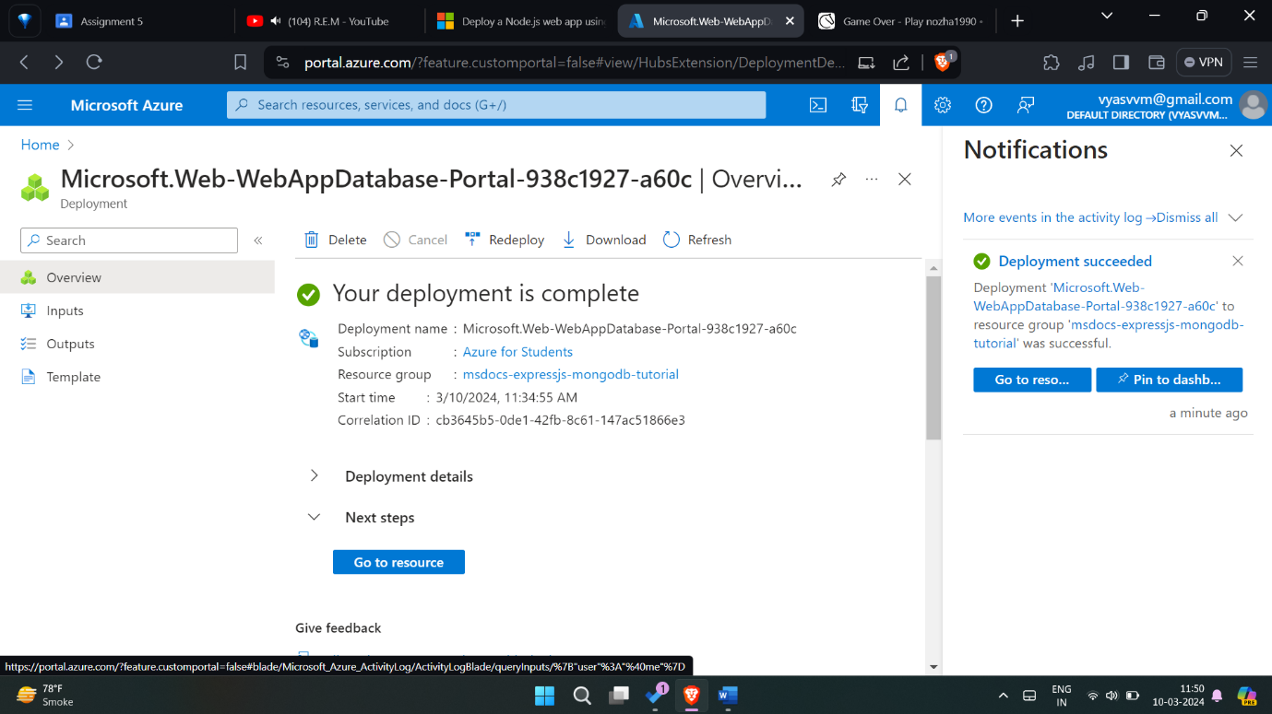

**Adding environment variables**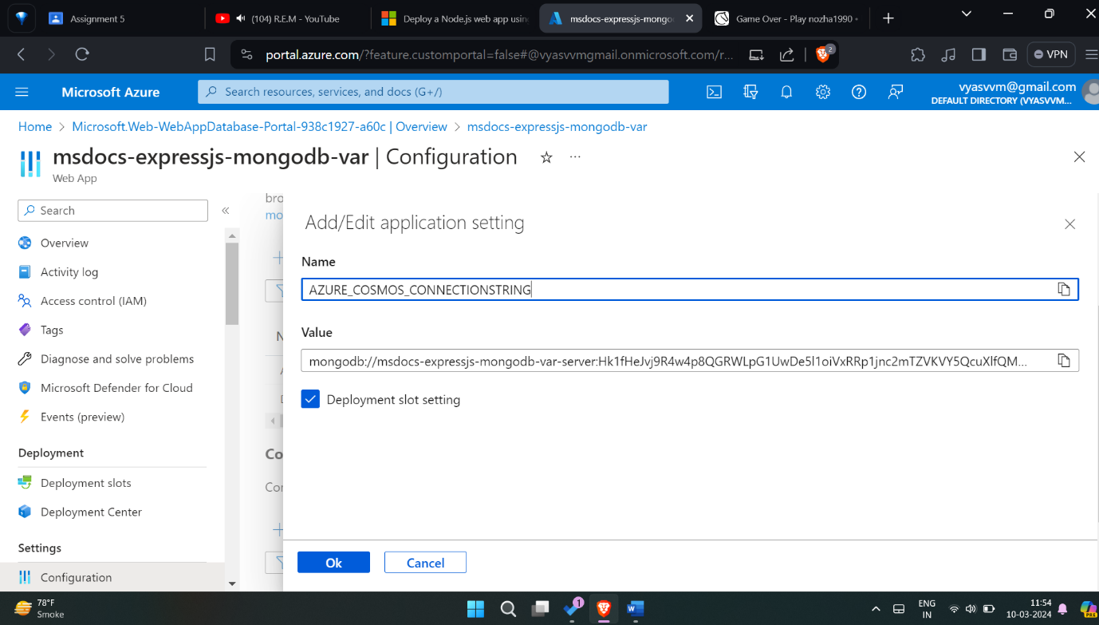

**Forking the github code**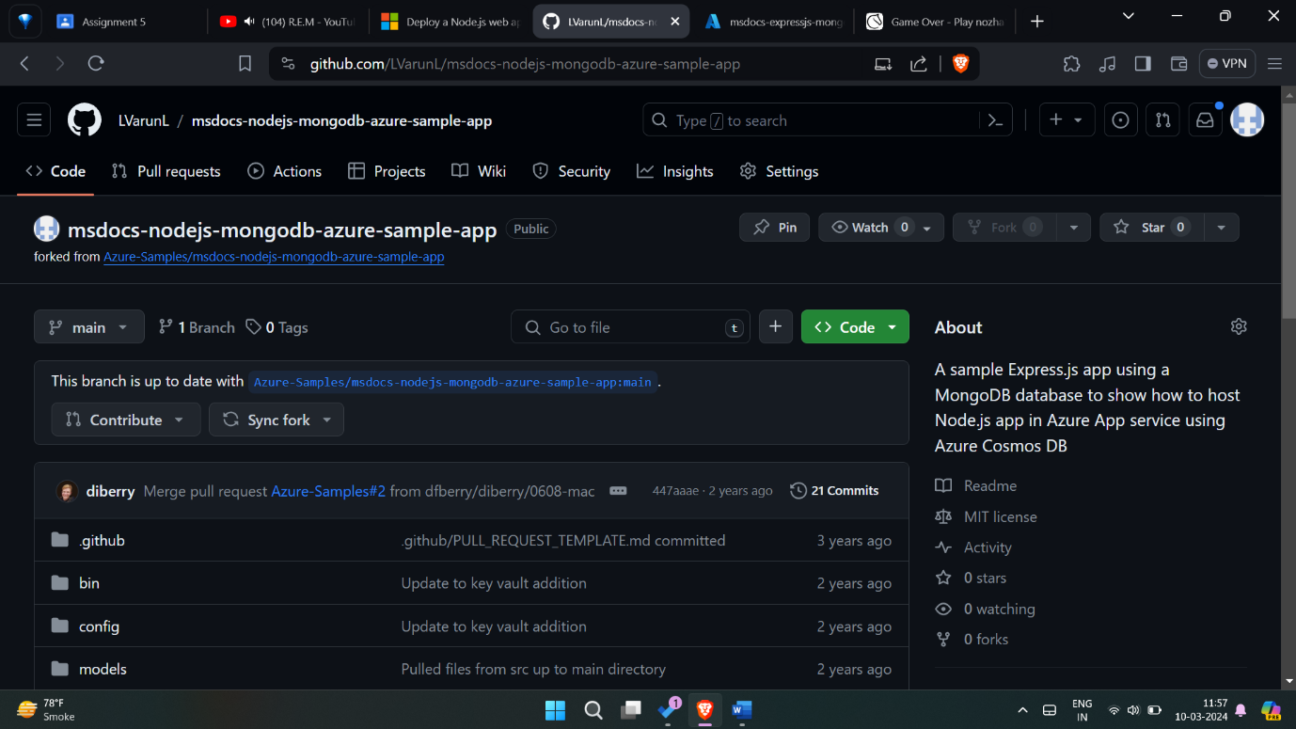

**Deploying on the app service from GitHub repository**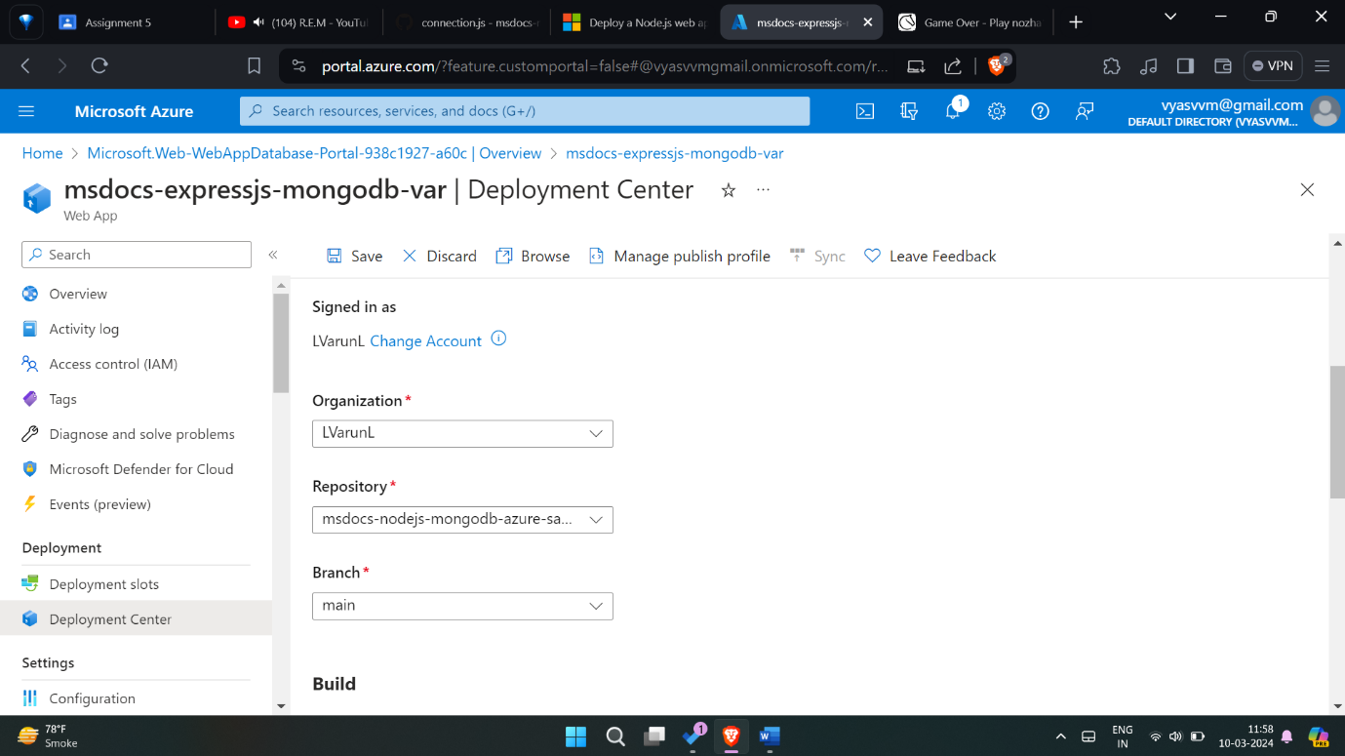

**Deployment action in GitHub**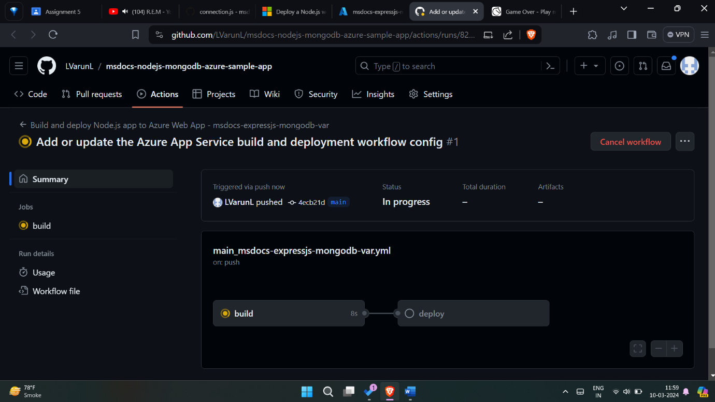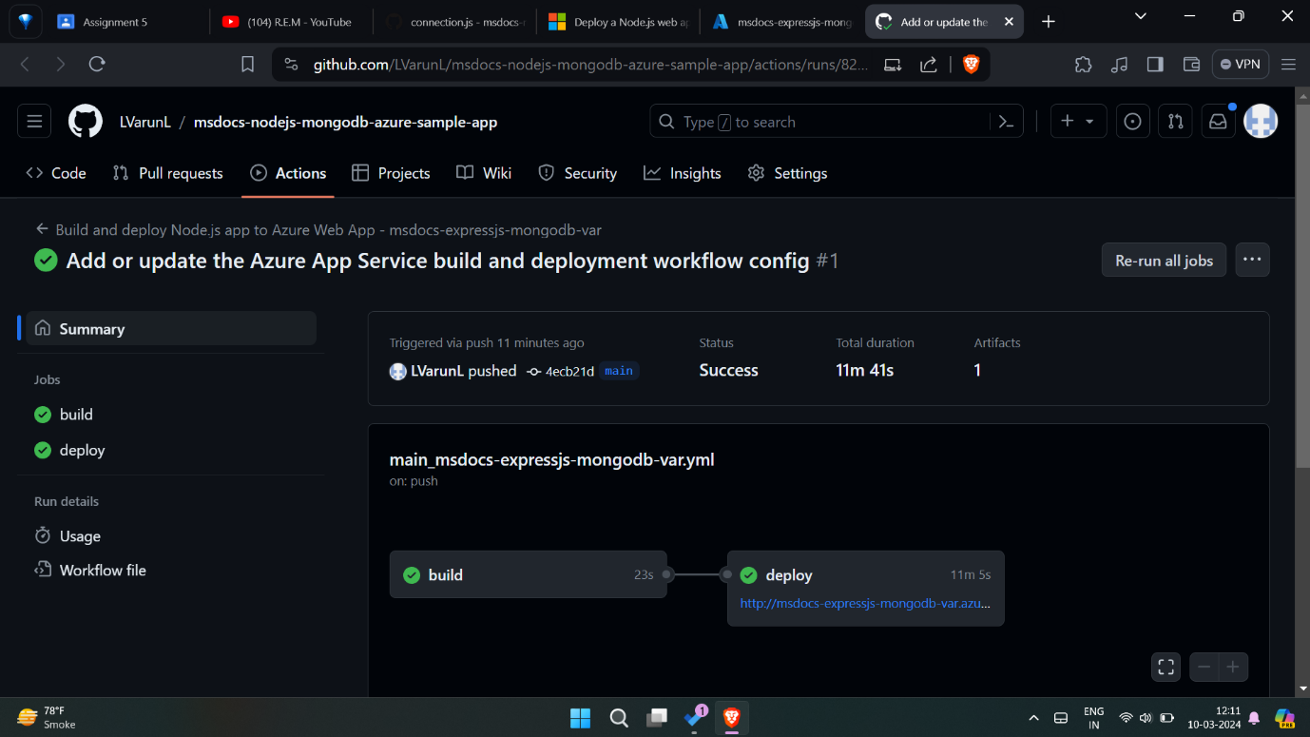

**Web app connected to its database and deployed on azure**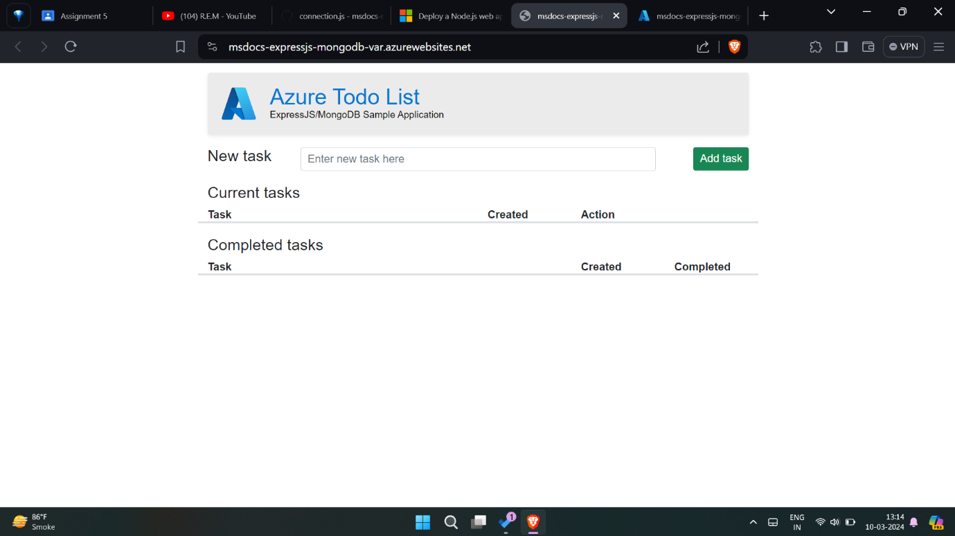

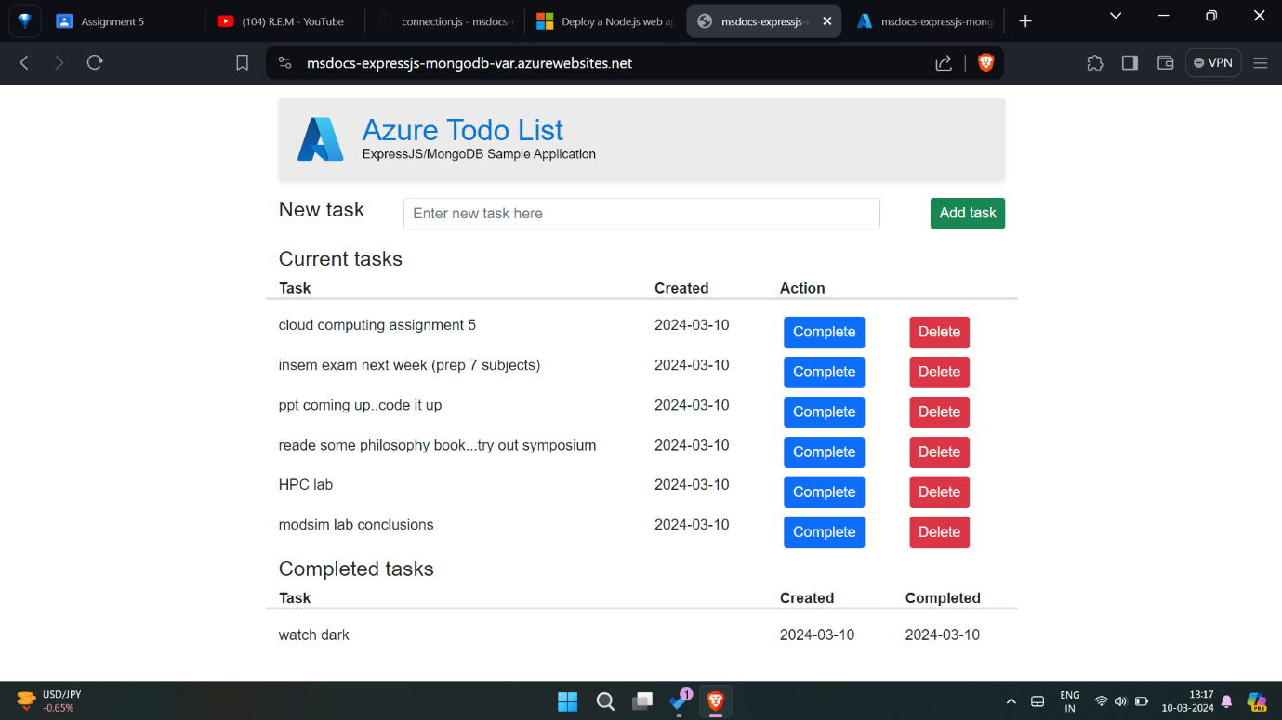

**App service logs**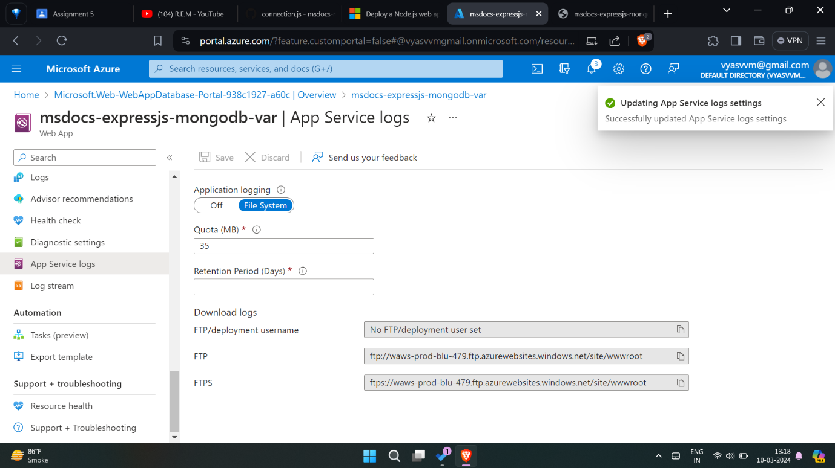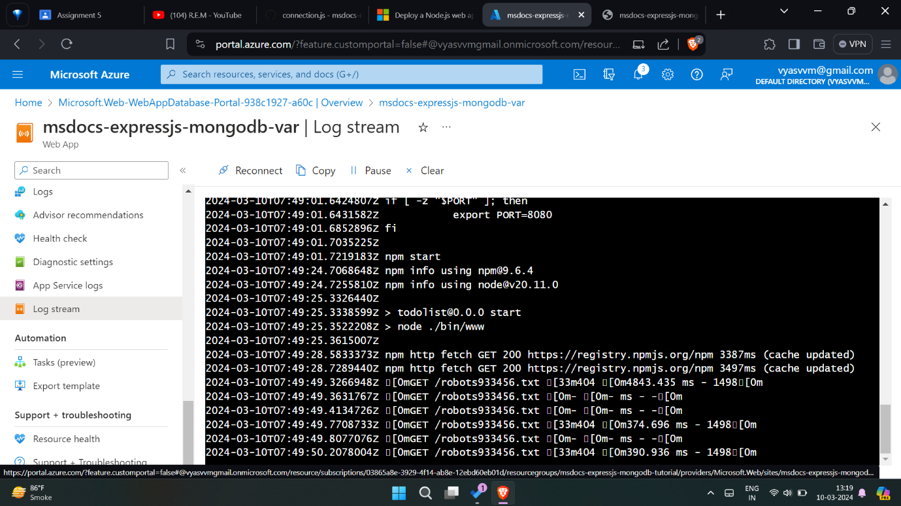

**Using Kudu** 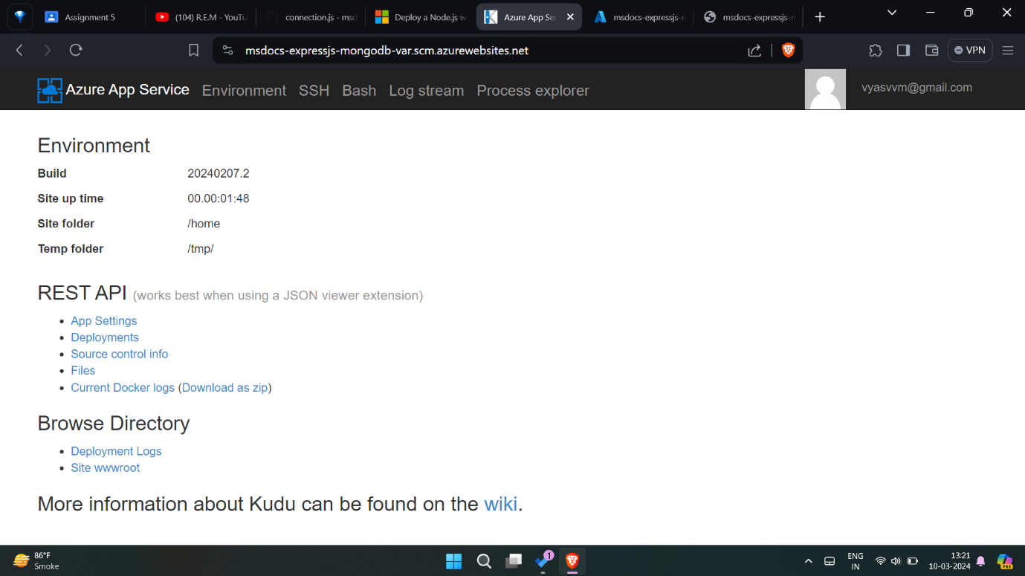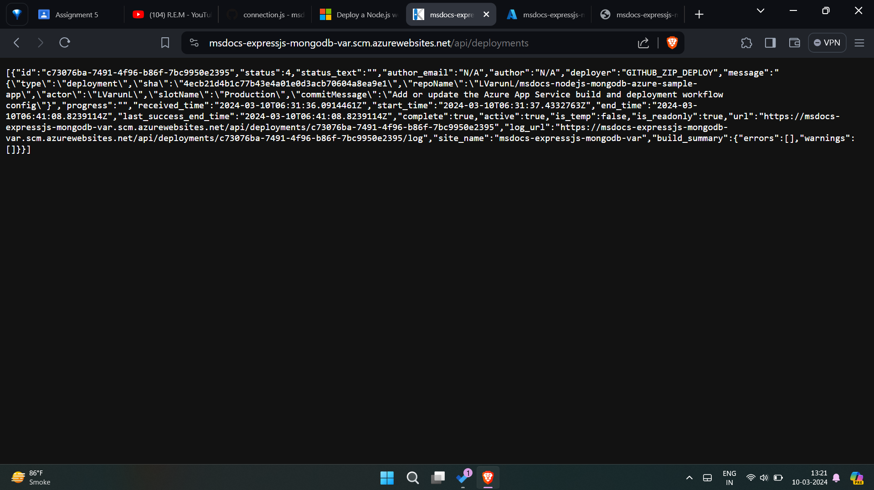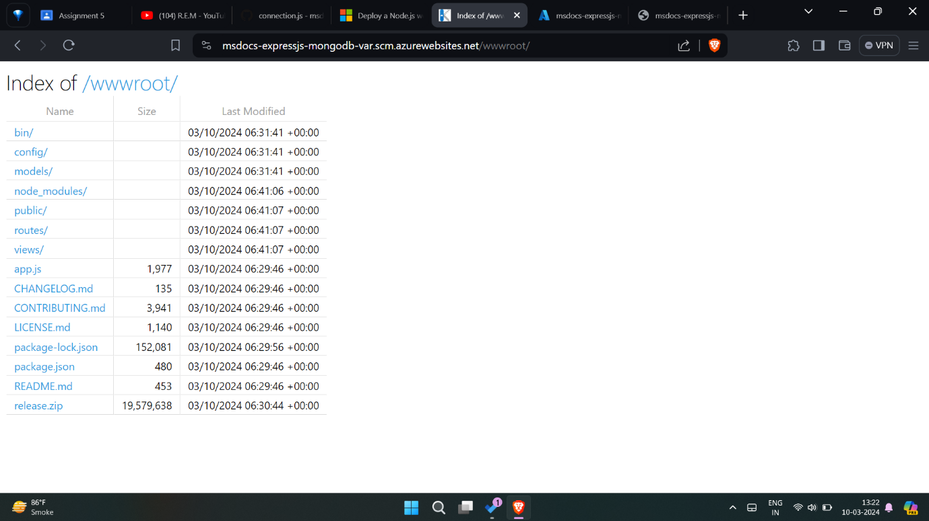

**Scaling up the web application**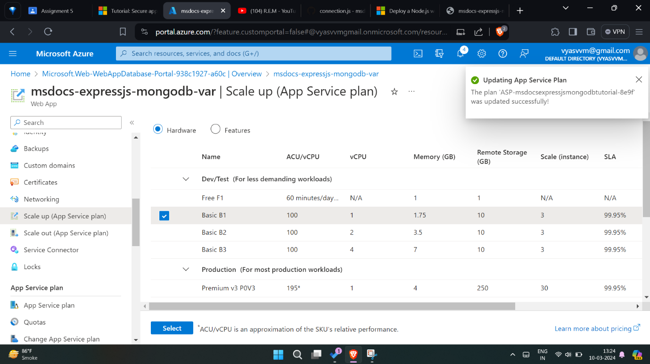

**Adding custom domain – (not attaching the entire process images as buying custom domains is not avaialble in student account of Azure.)**